Class Time:
Names:

F Distribution and ANOVA: ANOVA Lab 1

Student Learning Outcome:
- The student will conduct a simple ANOVA test involving three variables.
Collect the Data
- Record the price per pound of 8 fruits, 8 vegetables, and 8 breads in your local supermarket.
Fruits | Vegetables | Breads
- Explain how you could try to collect the data randomly.

Analyze the Data and Conduct the Hypothesis Test
- Compute the following:
Fruit:
- = _______
- s_{x} = _______
- n = _______

Vegetable:
- = _______
- s_{x} = _______
- n = _______
Bread:
- = _______
- s_{x} = _______
- n = _______
- Find the following
  - df(num) = _______
  - df(denom) = _______
- State the approximate distribution for the test.

- Test statistic: F = _______

- Sketch a graph of this situation. CLEARLY, label and scale the horizontal axis and shade the region(s) corresponding to the p-value.

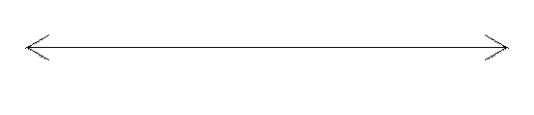

- Test at α = 0.05. State your decision and conclusion.
- Decision: Why did you make this decision?

- Conclusion (write a complete sentence).

- Based on the results of your study, is there a need to further investigate any of the food groups’ prices? Why or why not?

